**Final Project**

**Team Galaxy**

**Info 364**

**Project Guidelines and Deliverables**

## **Ugochukwu Etudo**

**Virginia Commonwealth University**

**5/3/2022**

**Members**

Charles Bonsu

Natalie Ramdeo

Ashraful Rumi

**Project Deliverable**

We propose a database system for a pet store that makes it so pet owners can purchase items for their pets and allow employees to purchase merchandise when needed for the store. The store will also sell pets such as dogs. This will allow our customers to have a one-stop shop for all pet-related needs. Customers can buy food, medicine, toys, collars, and accessories at checkout. Employees can also purchase items from suppliers when stock is low.

**Business Rules**

1. Compliance with applicable laws and regulations
2. Make sure to display items that are available or out of stock
3. Allow employees to restock items when given permission to do so
4. Update and revise the policy as necessary

**User Requirements**

User groups: Customers, Employees, Merchandise, Animals, and Inventory

Non-Functional Requirements

1. Operational Requirements
   * System needs to be able to access the internet
   * System can search for items in the database for Employees
   * System checks out customers and removes Inventory
   * System needs to back up regularly
2. Performance Requirements
   * System will update customer information after registering
   * System will update inventory regularly
   * System needs to be available 24/7
3. Security Requirements
   * Personal information of the customers will be confidential and only the Pet store owner has access to it.
   * Employee ID information is kept separate from the customers and animals.
   * Customers will have a user ID to log in.

**Requirements for EERD**

The Customer places an order at Checkout which is handled by an Employee. Each checkout will contain a unique OrderID.

**EERD**

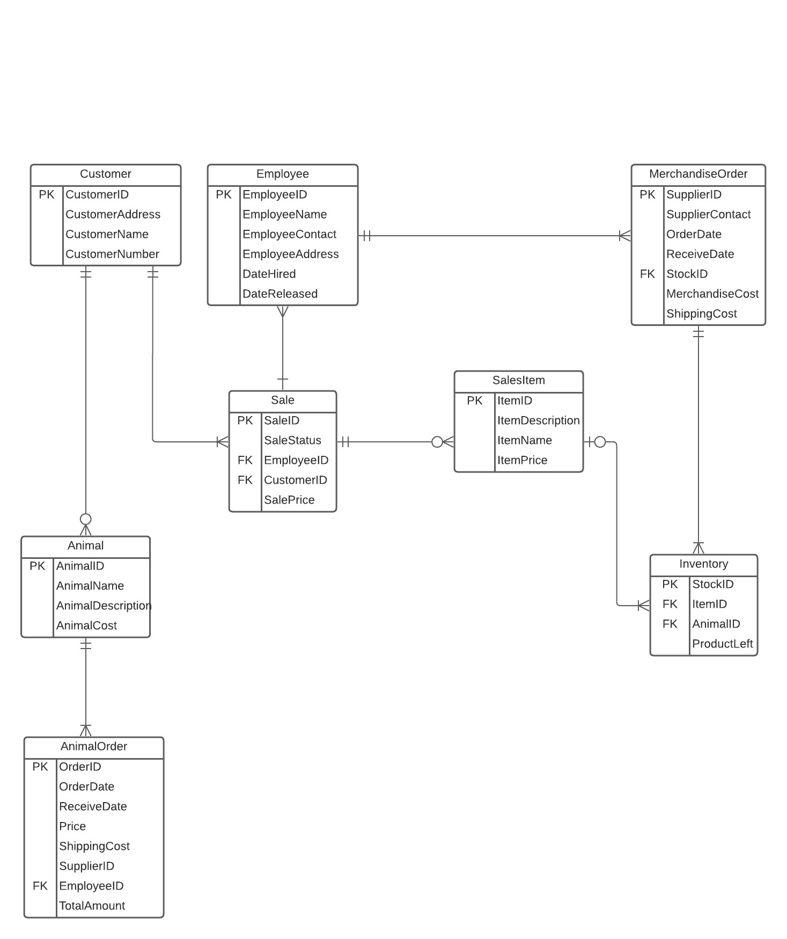

**Definitions**

**Animal** - This table will store the information of the different pets in store

* AnimalID - This is the primary key of the table.
* AnimalDescription - the detailed description of the pet such as the color, weight, height, Type etc.
* AnimalName - Name of pet if it already has one
* AnimalCost - This refers to the price for the pet

**AnimalOrde**r - This table stores the order information of the customer buying a pet

* OrderID - primary key of the table
* OrderDate - This refers to the date ther order was made
* ReceiveDate - This refers to the date the order was delivered
* AnimalOrder - This is a foreign key that links to the price of the pet
* ShippingCost - This refers to the cost for delivery to a specific location
* SupplierID - This is a forign key that links to MerchandiseOrder
* EmployeeID - This refers to the employee who handled the transaction
* TotalAmount - This refers to the total amount of the ordered products

**Customer** - This table will store the customers information

* CustomerID - The primary key for this table
* CustomerAddress - This refers to the address of the customer
* CustomerName - Full name of the customer
* CustomerNumber - Contact information of the customer

**Employee** - This table will store the employees information

* EmployeeID - Primary key for this table
* EmployeeName - Full name of employees
* EmployeeContact - Contact Information of employees
* EmployeeAddress - This refers to the address of the employee
* DateHired - This refers to the the date employees were hired
* DateRealesed - This refers to the date employees were fired

**Sale** - This table will store payment information

* SaleID - Primary key for this table
* SaleStatus - This refers to how the payment was made
* CustomerID - This is a foreign key that stores the customer who made the payment
* SalePrice - This refers to the amount made by the customer

**SalesItem** - This table stores the order information of the customer buying an item for their pet.

* ItemID - Primary key for this table
* ItemDescription - the detailed description of the pet item such as size, color, what pet it is for etc.
* ItemName - This refers to the name given to the item
* ItemPrice - The refers to the price of the item

**MerchandiseOrder** - this table will store the information of the company/person that the store receives the items and pets from

* SupplierID - Primary key of the table
* SupplierContact - contact information of the company/person (Email, phone number, name)
* OrderDate - This refers to the date merchandise was order
* RecieveDate - This refers to the date merchandise was received by the store
* EmployeeID - This refers to the to the employee who accepted the order from the company/person
* MerchandiseCost - This refers to the total amount it will cost the store to restock
* StockID - This refers to the total number of items needed to be replaced.

**Inventory** - this table will store the information of the current status of the stores inventory

* StockID - Primary key of the table
* ItemID - This is a foreign key that links this table to Salesitem
* AnimalID - This is a foreign key that links this table to Animal
* ProductLeft - This refers to the amount of each product we have left

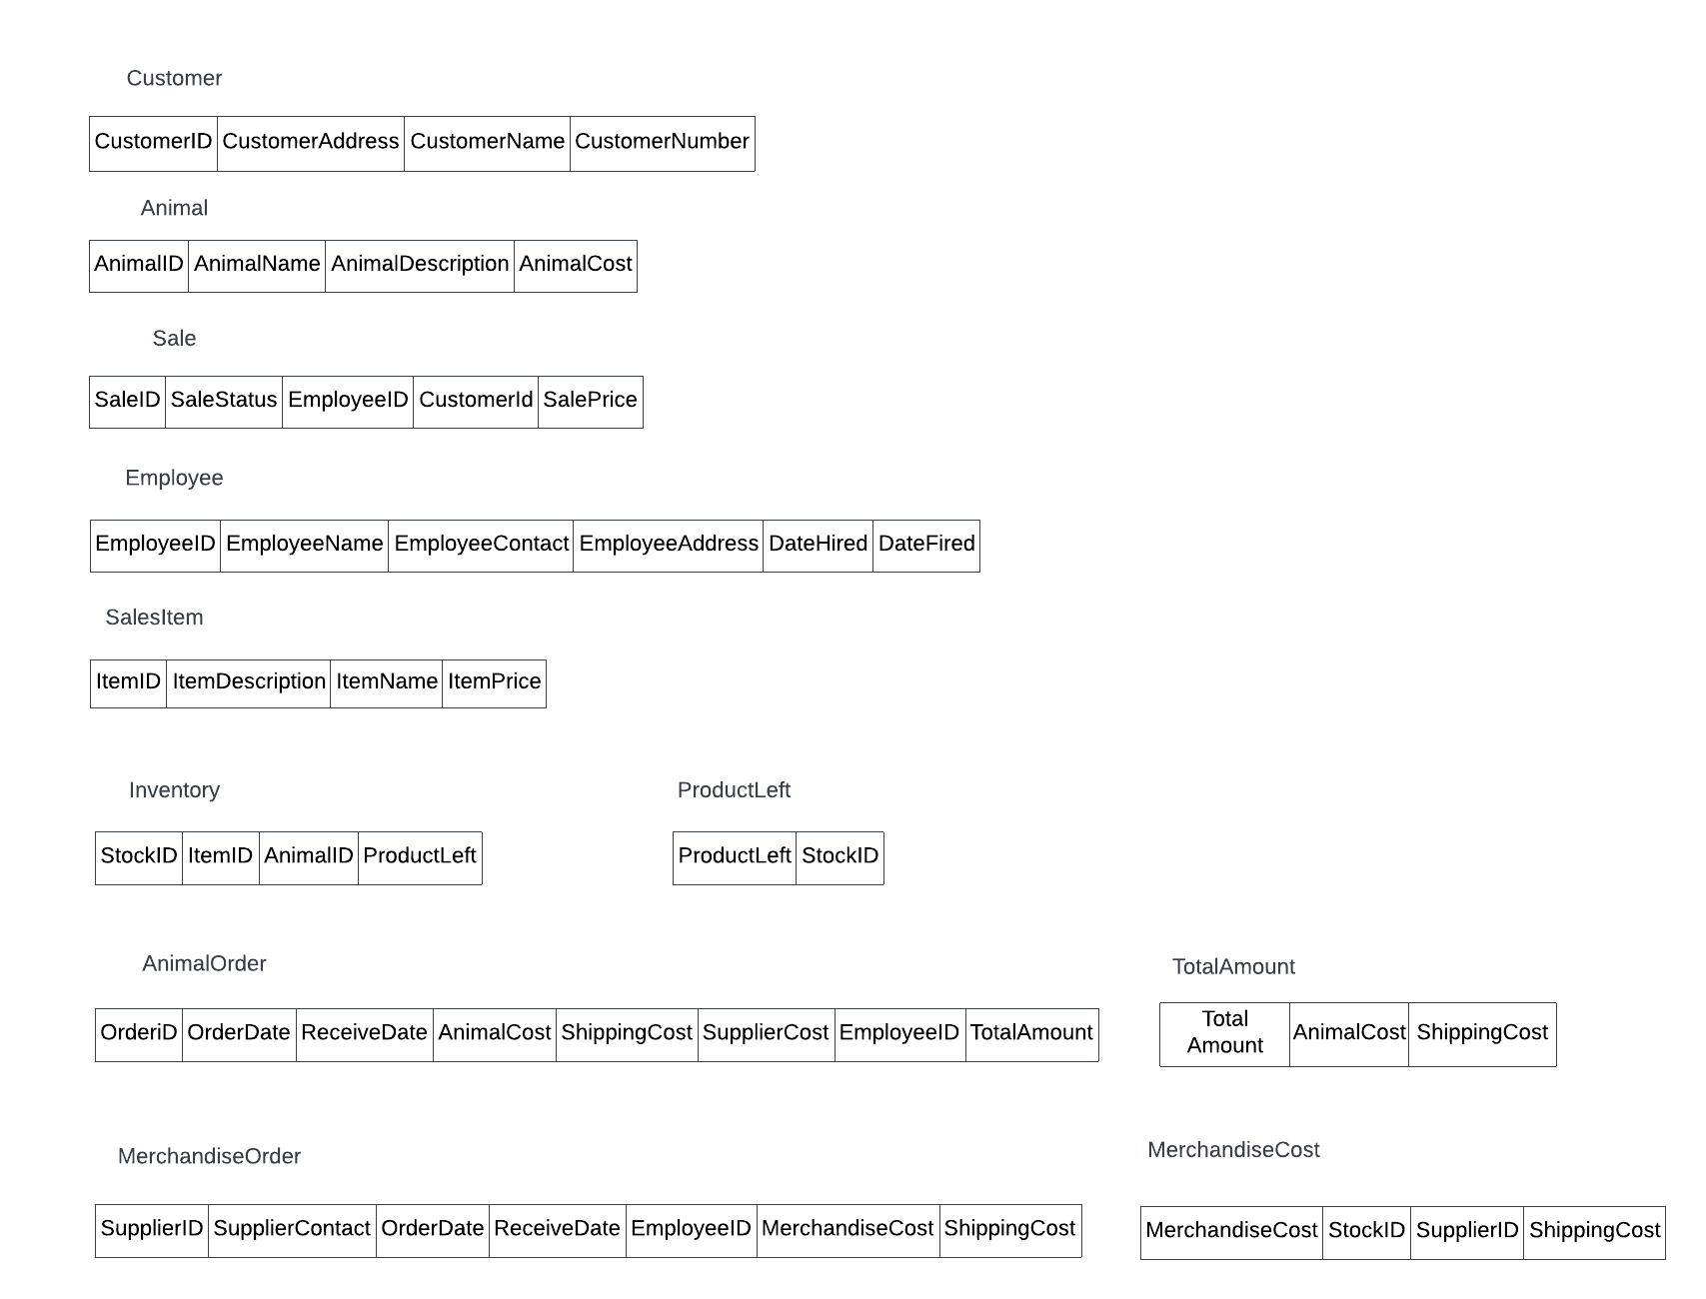

**SQL QUERIES**

